From backend create a instance

$ aws ec2 run-instances \
--region ap-south-1 \
--image-id ami-00ca570c1b6d79f36 \
--instance-type t3.micro \
--key-name mynewkeypem \
--count 1
{
"ReservationId": "r-0ab4ddffb63e166ba",
"OwnerId": "980100199479",
"Groups": [],
"Instances": [
{
"Architecture": "x86_64",
"BlockDeviceMappings": [],
"ClientToken": "ee15d4e0-97d5-445e-9f4c-95279cddaa1d",
"EbsOptimized": false,
"EnaSupport": true,
"Hypervisor": "xen",
"NetworkInterfaces": [
{
"Attachment": {
"AttachTime": "2025-12-24T17:10:37+00:00",
"AttachmentId": "eni-attach-0ff525ad58ca08155",
"DeleteOnTermination": true,
"DeviceIndex": 0,
"Status": "attaching",
"NetworkCardIndex": 0
},
"Description": "",
"Groups": [
{
"GroupId": "sg-0ad1d5b3dd760bbab",
"GroupName": "default"
}
],
"Ipv6Addresses": [],
"MacAddress": "0a:a9:2a:6e:5a:05",
"NetworkInterfaceId": "eni-0260daec3ba9c984e",
"OwnerId": "980100199479",
"PrivateDnsName": "ip-172-31-4-6.ap-south-1.compute.internal",
"PrivateIpAddress": "172.31.4.6",
"PrivateIpAddresses": [
{
"Primary": true,
"PrivateDnsName": "ip-172-31-4-6.ap-south-1.compute.internal",
"PrivateIpAddress": "172.31.4.6"
}
],
"SourceDestCheck": true,
"Status": "in-use",
"SubnetId": "subnet-0cbff28a2f9d6ac58",
"VpcId": "vpc-019de54c3939a2a46",
"InterfaceType": "interface",
"Operator": {
"Managed": false
}
}
],
"RootDeviceName": "/dev/xvda",
"RootDeviceType": "ebs",
"SecurityGroups": [
{
"GroupId": "sg-0ad1d5b3dd760bbab",
"GroupName": "default"
}
],
"SourceDestCheck": true,
"StateReason": {
"Code": "pending",
"Message": "pending"
},
"VirtualizationType": "hvm",
"CpuOptions": {
"CoreCount": 1,
"ThreadsPerCore": 2
},
"CapacityReservationSpecification": {
"CapacityReservationPreference": "open"
},
"MetadataOptions": {
"State": "pending",
"HttpTokens": "required",
"HttpPutResponseHopLimit": 2,
"HttpEndpoint": "enabled",
"HttpProtocolIpv6": "disabled",
"InstanceMetadataTags": "disabled"
},
"EnclaveOptions": {
"Enabled": false
},
"BootMode": "uefi-preferred",
"PrivateDnsNameOptions": {
"HostnameType": "ip-name",
"EnableResourceNameDnsARecord": false,
"EnableResourceNameDnsAAAARecord": false
},
"MaintenanceOptions": {
"AutoRecovery": "default",
"RebootMigration": "default"
},
"CurrentInstanceBootMode": "uefi",
"Operator": {
"Managed": false
},
"InstanceId": "i-02a9857535345c9e7",
"ImageId": "ami-00ca570c1b6d79f36",
"State": {
"Code": 0,
"Name": "pending"
},
"PrivateDnsName": "ip-172-31-4-6.ap-south-1.compute.internal",
"PublicDnsName": "",
"StateTransitionReason": "",
"KeyName": "mynewkeypem",
"AmiLaunchIndex": 0,
"ProductCodes": [],
"InstanceType": "t3.micro",
"LaunchTime": "2025-12-24T17:10:37+00:00",
"Placement": {
"AvailabilityZoneId": "aps1-az3",
"GroupName": "",
"Tenancy": "default",
"AvailabilityZone": "ap-south-1b"
},
"Monitoring": {
"State": "disabled"
},
"SubnetId": "subnet-0cbff28a2f9d6ac58",
"VpcId": "vpc-019de54c3939a2a46",
"PrivateIpAddress": "172.31.4.6"
}
]
}
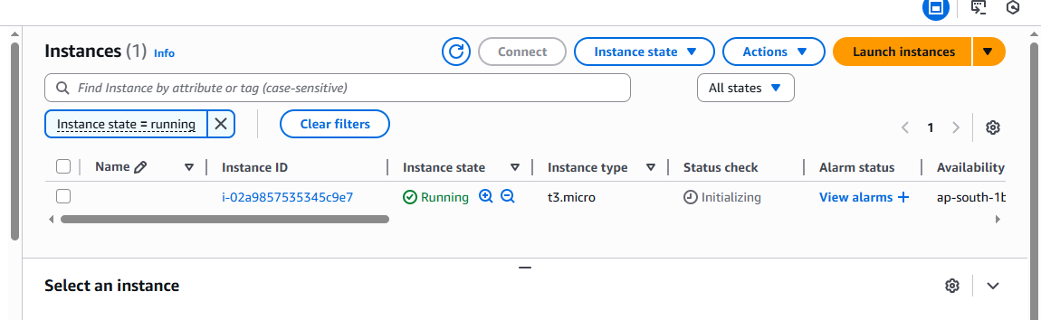

Stop and terminate running instance from backend

